Tenderstem Broccoli Information Pack
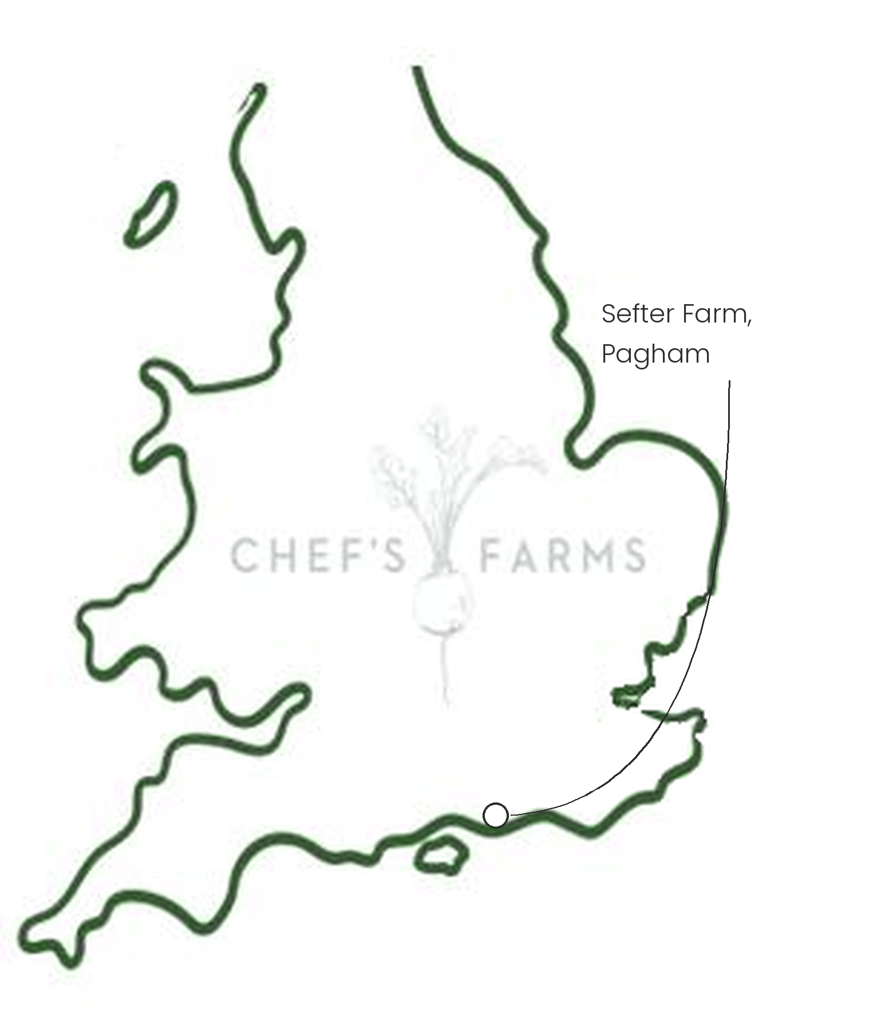
Introduction
Tenderstem is a cross between broccoli and Chinese kale, bred in Japan in the 1990s. The whole stem is tender and sweet, so there is nothing to trim and it cooks in minutes.
Farm Information
Our Tenderstem is grown by Barfoots at Sefter Farm in Pagham, just down the road from us in West Sussex. Peter Barfoot started the business here in 1976 and it has since grown into one of the UK's leading vegetable growers, while still farming from the same spot on the coastal plain.
This corner of West Sussex is one of the sunniest in the country, and the fertile, free-draining soils make it ideal for growing veg. Tenderstem is cut by hand, as the plant keeps throwing out new shoots after the first harvest, so the same field is picked over several times through the season.
Nothing goes to waste at Sefter Farm either. Trimmings and veg that don't make the grade go into the farm's anaerobic digester, which turns them into renewable energy, with the leftover digestate going back onto the land as fertiliser.
A local grower working at serious scale, and we are incredibly proud to have them on our doorstep.
More
The UK season runs from early summer into autumn. Being so tender, it only needs two or three minutes in boiling water, or goes straight onto the chargrill with no blanching at all.
Nutritionally, Tenderstem is a good source of vitamin C, folate and vitamin K.
Media
See shared album

